# TUDO

## abril e maio:

Estudo sobre diferentes tecnologias de comunicação remota via Android para controle de dispositivos microcontrolados, entre elas: Bluetooth, Radiofrequência, WiFi, etc. Pesquisa sobre módulos disponíveis no mercado. Documentação do estudo.

## Conclusões:

### Tabela

|  |  |  |  |  |
| --- | --- | --- | --- | --- |
|  |  | Distância | Responsividade | Preço |
| Rede Celular | GSM / GPRS |  |  |  |
| Lora | Lorawan | 200 m / 400m / 6,5 km com antena |  |  |
| Wifi | ESP32 | 152 m |  |  |
| Wifi | ESP8266 | 479 antena / 366 meters antenna PCB |  |  |
| Bluetooth | HC05 | 10m |  |  |
| Bluetooth | HC06 |  |  |  |
| RFID | RFid |  |  |  |
|  | arduino mkr1000 |  |  |  |

|  |  |  |  |  |
| --- | --- | --- | --- | --- |
| ESP8266 | 80MHz | WiFi | 160KiB | 16 GPIO |
| ESP32 | 240MHz | WiFi / BLE / BT | 520KiB | 23 GPIO |

https://youtu.be/ZAqNKaX3LQ0

### RFid:

Geralmente de curto alcance, ações limitadas ao que for programado em cartões de RFid. Inviável.

### Protocolo CAN:

Alcance até 40 metros, requere um dispositivo de envio e outro de recebimento, permite envio de até 11 bits ou 29 bits. Parece viável, mas não para o caso do controle por Smartphone (SP), a não ser que fosse configurado:

SP+Bluetooth (envia) -> Arduino1+Bluetooth (recebe) + MCP2515 (envia) -> Arduino2+MCP2515 (recebe)+servomotores

O que aumentaria desnecessariamente a complexidade, visto que pode-se fazer o mesmo com o bluetooth sem a necessidade do MCP.

### ESP32 LoraWan:

Longo alcance: 3,6 km.

### Wifi

### Bluetooth:

## Pesquisar Depois

<https://www.arduinoecia.com.br/como-usar-serial-plotter-no-arduino/>

Arduino to Arduino: https://youtu.be/Kq4jUWbJIXI

BLYNK: <https://www.filipeflop.com/blog/como-usar-modulo-rele-wifi-esp8266-blynk/>

<https://www.arduinoecia.com.br/como-usar-serial-plotter-no-arduino/>

## Tecnologias

### 1

<https://www.youtube.com/watch?v=-EA9UBEahDY>

Zigby, nfc, bluetooth, rede celular, WIFI

Oq diferencia? A quantidade de dados (largura de banda) a serem transmitidos e a distância.

LPone (novas tecnologias) LORA, zigfox.

Análise de Dados é o coração da IOT, sem isso, não é IOT

Interoperabilidade entre tecnologias

Segurança

RFD

### 2

<https://www.youtube.com/watch?v=NxGklKldtzs>

renesas

st life augmented

microchip [IOT]

Bluetooth 5.0

Bluetooth com possibilidade de Mesh

Mesh: cada dispositivo da rede tem um repetidor, mesmo que seja um alcance pequeno.

Sigfox e LoRa

Distância maior do que Bluetooth

Sigfox, usa infraestrutura de uma operadora

Lora, pode-se construir sua infraestrutura

NB-IoT: Usa uma faixa estreita, consome pouco, e usa rede de celular. Trocar modem 3g, 4g por um modem NB-IoT e tem menor consumo de energia e dados.

ARMmbed

Desafio IOT desenvolvido pela IOT Brasil

LTE

### 3

#### **IoT standards and frameworks**

##### IPv6 over Low-Power Wireless Personal Area Networks (6LoWPAN)

is an open standard defined by the Internet Engineering Task Force ([IETF](https://whatis.techtarget.com/definition/IETF-Internet-Engineering-Task-Force)). The 6LoWPAN standard enables any low-power radio to communicate to the internet, including 804.15.4, Bluetooth Low Energy ([BLE](https://internetofthingsagenda.techtarget.com/definition/Bluetooth-Low-Energy-Bluetooth-LE)) and [Z-Wave](https://internetofthingsagenda.techtarget.com/definition/Z-Wave) (for home automation).

##### ZigBee

is a low-power, low-data rate wireless network used mainly in industrial settings. ZigBee is based on the Institute of Electrical and Electronics Engineers (IEEE) 802.15.4 standard. The ZigBee Alliance created Dotdot, the universal language for IoT that enables smart objects to work securely on any network and understand each other.

##### [LiteOS](https://whatis.techtarget.com/definition/LiteOS)

is a Unix-like operating system (OS) for wireless sensor networks. LiteOS supports smartphones, [wearables](https://searchmobilecomputing.techtarget.com/definition/wearable-technology), intelligent manufacturing applications, [smart homes](https://internetofthingsagenda.techtarget.com/definition/smart-home-or-building) and the internet of vehicles ([IoV](https://whatis.techtarget.com/definition/Internet-of-Vehicles)). The OS also serves as a smart device development platform.

##### OneM2M

is a machine-to-machine service layer that can be embedded in software and hardware to connect devices. The global standardization body, OneM2M, was created to develop reusable standards to enable IoT applications across different verticals to communicate.

##### Data Distribution Service (DDS)

was developed by the Object Management Group ([OMG](https://searchapparchitecture.techtarget.com/definition/Object-Management-Group-OMG)) and is an IoT standard for real-time, scalable and high-performance [M2M](https://internetofthingsagenda.techtarget.com/definition/machine-to-machine-M2M) communication.

##### Advanced Message Queuing Protocol ([AMQP](https://whatis.techtarget.com/definition/Advanced-Message-Queuing-Protocol-AMQP))

is an open source published standard for asynchronous messaging by wire. AMQP enables encrypted and interoperable messaging between organizations and applications. The protocol is used in [client-server](https://searchnetworking.techtarget.com/definition/client-server) messaging and in IoT device management.

##### Constrained Application Protocol ([CoAP](https://whatis.techtarget.com/definition/Constrained-Application-Protocol))

is a protocol designed by the IETF that specifies how low-power, compute-constrained devices can operate in the internet of things.

##### Long Range Wide Area Network (LoRaWAN)

is a protocol for WANs designed to support huge networks, such as smart cities, with millions of low-power devices.

#### **IoT frameworks include the following:**

##### Amazon Web Services (AWS) IoT

is a cloud computing platform for IoT released by Amazon. This framework is designed to enable smart devices to easily connect and securely interact with the AWS cloud and other connected devices.

##### Arm Mbed IoT

is a platform to develop apps for IoT based on Arm microcontrollers. The goal of the Arm Mbed IoT platform is to provide a scalable, connected and secure environment for IoT devices by integrating Mbed tools and services.

##### Microsoft's Azure IoT Suite

is a platform that consists of a set of services that enables users to interact with and receive data from their IoT devices, as well as perform various operations over data, such as multidimensional analysis, transformation and aggregation, and visualize those operations in a way that's suitable for business.

##### Google's Brillo/Weave

is a platform for the rapid implementation of IoT applications. The platform consists of two main backbones: Brillo, an Android-based OS for the development of embedded low-power devices, and Weave, an IoT-oriented communication protocol that serves as the communication language between the device and the cloud.

##### Calvin

is an open source IoT platform released by Ericsson designed for building and managing distributed applications that enable devices to talk to each other. Calvin includes a development framework for application developers, as well as a runtime environment for handling the running application.

## Pesquisa

6LoWPAN

<https://www.l-tek.com/web-shop/l-tek-6lowpan-arduino-shield-900mhz/>

## Análise das tecnologias

Zigbee, nfc, bluetooth, rede celular, WIFI, LPone, LORA, Zigfox, RFD, Renesas, st life augmented, Bluetooth 5.0, Bluetooth com possibilidade de Mesh, NB-IoT, ARMmbed, LTE, 6LoWPAN, LiteOS, OneM2M, Data Distribution Service (DDS), Advanced Message Queuing Protocol (AMQP), Constrained Application Protocol (CoAP), Long Range Wide Area Network (LoRaWAN), AWS IoT, Arm Mbed IoT, Microsoft’s Azure IoT Suite, Google’s Brillo/ Weave, Calvin

### Comparação 1 Sigfox vs LoRa

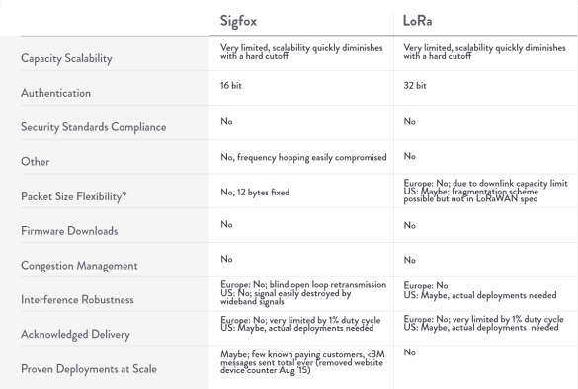

### Comparação 2 lpwan, cellular, zigbee, ble, wifi, rfid

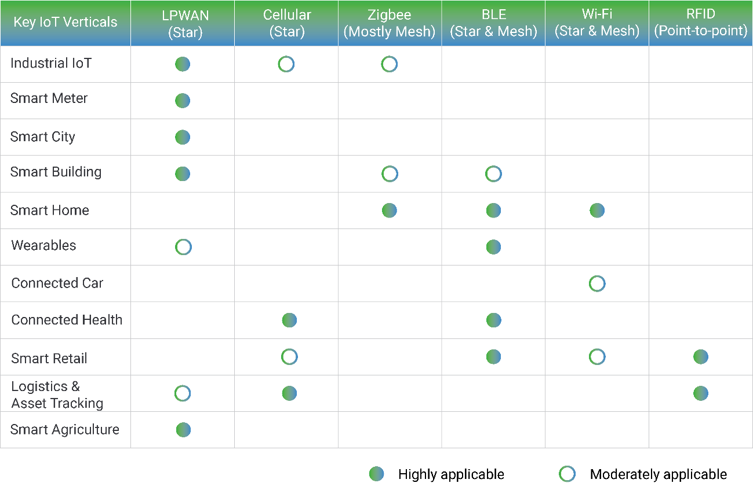

### Segurança:

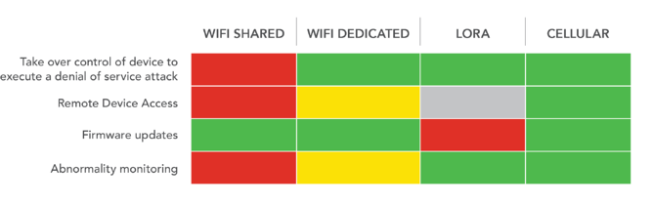

### 40 emerging iot technologies

Importante:

<https://iot-analytics.com/40-emerging-iot-technologies-you-should-have-on-your-radar/>

#### Radar

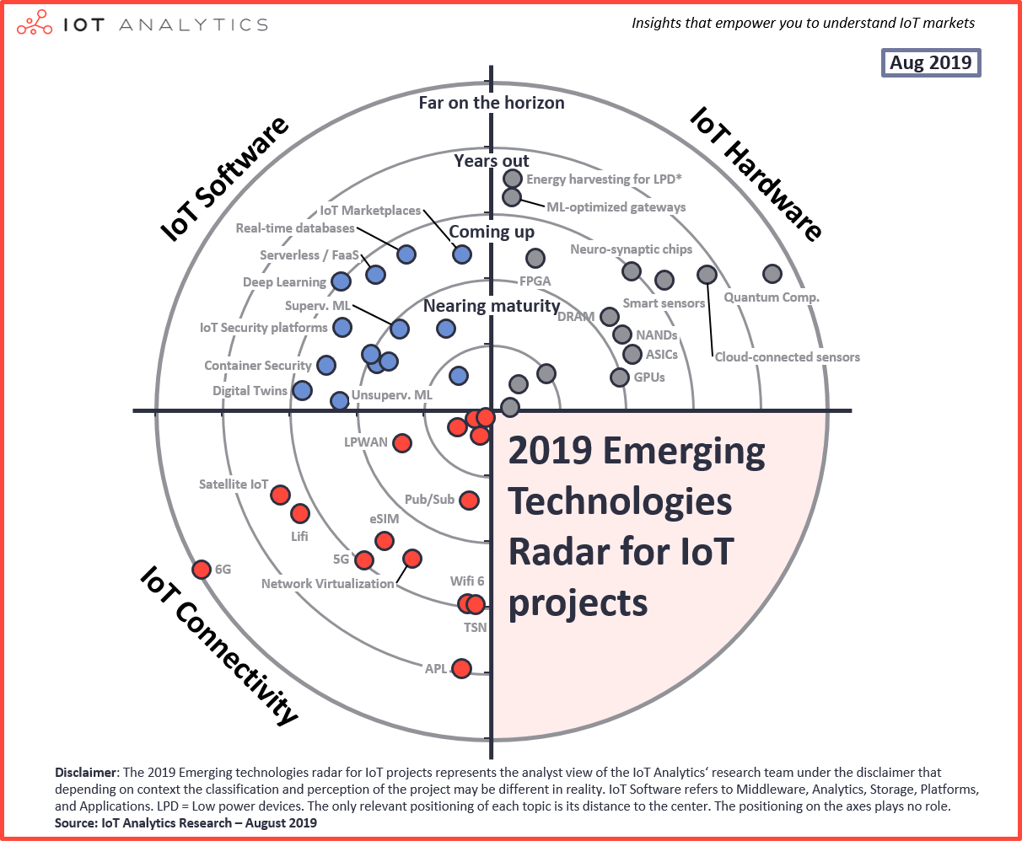

#### A. IoT Software Technologies

| **#** | **Technology** | **Description** | **Classification** | **Typical vendor(s) or solutions** |
| --- | --- | --- | --- | --- |
| **1** | **Cloud computing** | Using a network of remote servers to store, manage, and process data. | Fairly Mature | AWS, Microsoft Azure, Alibaba Aliyun |
| **2** | **IoT Platforms** | Form of modular software that allow easy connection of various IoT devices & other value-added functionality (e.g., remote device management, application enablement, analytics) | Nearing maturity | AWS IoT, Microsoft Azure IoT, PTC Thingworx |
| **3** | **Edge analytics** | Collection and analysis of data at the sensor, device, gateway or edge data center rather than waiting for the data to be sent back to a remote cloud. | Nearing maturity | AWS IoT Greengrass, Microsoft IoT Edge, Foghorn, Crosser |
| **4** | **IoT-based streaming analytics** | Real time processing of streaming of data from IoT devices | Nearing maturity | Cloud vendor solutions, Hortonworks Dataflow, SAS, Software AG |
| **5** | **Supervised machine learning** | ML method where training data for the algorithm includes desired outputs. | Nearing maturity | Uptake, Sparkcognition, Senseye |
| **6** | **Unsupervised machine learning** | ML method where training data for the algorithm does not include the desired outputs. | Nearing maturity | Uptake, Sparkcognition, Darktrace |
| **7** | **Containers** | Containers are processes with their own virtual resources and filesystems (memory, CPU, disk, etc.), isolated from other applications and containers | Nearing maturity | Docker, Kubernetes, OpenShift |
| **8** | **IoT Marketplaces** | A one-stop click-and-buy-store, offering complete Internet of Things solutions ready to deploy smart applications including hardware, software and cloud connection. | Coming up | PTC, Siemens, ABB, Schneider Electric, Inductive Automation |
| **9** | **Digital Twins** | Digital representation of physical assets, processes, systems and devices | Coming up | GE, Azure, Siemens, Honeywell, Emerson |
| **10** | **Container Security** | Solutions that protect the integrity of containers | Coming up | Cloud Vendor Solutions, Palo Alto Networks |
| **11** | **IoT Security platforms** | Platform offering security solutions for any IoT device class | Coming up | Mocana, Bayshore Networks, Device Authority |
| **12** | **Real-time database** | Database that uses real-time processing to handle constantly changing workloads | Coming up | MongoDB, Counchbase |
| **13** | **Serverless / FaaS** | Developing, running, and managing application functionalities without the complexity of building and maintaining the infrastructure associated with developing and launching an application | Coming up | AWS Lamda, IBM OpenWhisk, Google Cloud Functions |
| **14** | **Deep Learning** | Part of a broader family of machine learning methods based on artificial neural networks | Coming up | TensorFlow, Apache Mahout, Caffe, Deepmind, CuriousAI |

#### B. IoT Hardware Technologies

| **#** | **Technology** | **Description** | **Classification** | **Typical vendor(s) or solutions** |
| --- | --- | --- | --- | --- |
| **1** | **CPU** | Central processing unit | Fairly mature | Intel, HPE, AMD |
| **2** | **Security chips** | Security-enhancing low-powered modules, include various security-sensitive functions | Fairly mature | Apple, Alphabet |
| **3** | **Edge gateways** | Physical devices that serve as the connection point between the cloud and controllers, sensors and intelligent devices | Fairly mature | Dell, HPE |
| **4** | **GPUs** | Graphic processing unit | Coming up | NVIDIA, AMD, Asus, Intel |
| **5** | **NAND** | Non-volatile flesh memory | Coming up | Micron, Samsung, Toshiba |
| **6** | **ASIC** | Application-specific integrated circuit | Coming up | Fujitsu, Honeywell, Advanced Linear Devices |
| **7** | **DRAM** | Dynamic random-access memory | Coming up | Samsung, Micron, SK Hynics |
| **8** | **FPGA** | Field programmable gate array | Coming up | Xilinx, Intel, Altera |
| **9** | **Neuro-synaptic chip** | Brain-inspired computer chip, in which transistors simulate neurons and synapses | Coming up | IBM |
| **10** | **Smart sensors** | Sensors that take some predefined action when they sense the appropriate input | Years out | Texas Instruments, TE Connectivity, Broadcom |
| **11** | **ML-optimized gateways** | Controllers that are optimized for ML algorithms | Years out | Adlink, Intel |
| **12** | **Energy harvesting for LPD** | Supplying electricity to LPDs from one or several forms of available energy from the ambient environment instead of using disposable batteries or a connection to the electricity grid | Years out | STMicroelectronics, ABB |
| **13** | **Cloud-connected sensors** | Sensors that are sending data directly to the cloud | Years out | Schneider Electric |
| **14** | **Quantum computing** | Computation using quantum-mechanical phenomena e.g., superposition entanglement | Far on the horizon | IBM, Microsoft, Rigetti |

#### C. IoT Connectivity Technologies

| **#** | **Technology** | **Description** | **Classification** | **Typical vendor(s) or solutions** |
| --- | --- | --- | --- | --- |
| **1** | **WLAN** | Wireless Local Area Networks, includes Wi-Fi and its different versions | Fairly mature | Cisco, Aruba, Extreme Networks |
| **2** | **WPAN** | Wireless Personal Area Networks, incl. very short-range (up to ~100 m) connectivity technologies (e.g. BLE, Zigbee) | Fairly mature | DiGi Int., NXP Semiconductors, Silicon Labs |
| **3** | **Cellular IoT (2G/3G/4G)** | Provides connectivity to IoT applications via traditional cellular networks | Fairly mature | China Mobile, Vodafone, Orange |
| **4** | **WNAN** | Wireless Neighborhood Area Networks, includes medium-range (~500-2,000 km) mesh connectivity technologies based on the IEEE 802.15.4 standard (e.g. Wi-SUN) | Fairly mature | Itron/Silver Spring Networks, Wirepas |
| **5** | **LPWAN** | Low-Power Wide-Area connectivity for IoT applications (e.g. Sigfox, LoRa, NB-IoT, LTE-M) | Nearing maturity | Semtech, Sigfox |
| **6** | **Pub/Sub** | Form of asynchronous service-to-service comm. used in IoT messaging protocols e.g. MQTT, XMPP | Nearing maturity | AWS, Google Cloud, PubNub |
| **7** | **eSIM** | A SIM-card embedded into mobile devices that enables remote SIM provisioning, allowing storing of multiple operator profiles simultaneously and switching between them remotely. | Coming up | ST Microelectronics, Gemalto, Giesecke & Devrient, ARM |
| **8** | **Network Virtualization** | Abstracts network elements & resources into a logical virtual network that runs independently on top of a physical network | Coming up | Oracle, VMWare, Juniper Networks |
| **9** | **5G** | The fifth generation of cellular networks, commercially launched in 2019 | Coming up | Huawei, Ericsson, Nokia |
| **10** | **Wifi 6** | The newest version of the Wi-Fi protocol, also known as IEE 802.11ax | Coming up | Qualcomm, Cisco, Huawei |
| **11** | **TSN** | Time-Sensitive Networking is a set of standards defined by IEEE for the time-sensitive transmission of data over deterministic Ethernet networks | Coming up | ABB, Bosch, Cisco, Siemens |
| **12** | **Lifi** | Wireless communication technology that uses light to transmit data. | Years out | Panasonic, Oledcomm, Philips |
| **13** | **Satellite IoT** | Provides connectivity to IoT applications via satellite networks | Years out | Iridium, Inmarsat, Eutelsat |
| **14** | **APL (Advanced Physical Layer)** | Developing industrial Ethernet standard that seeks to leverage the work of the IEEE 802.3cg (10BASE-T1L) task force to achieve a single twisted-pair industrial Ethernet standard for hazardous areas | Years out | Pepperl+Fuchs, Endress+Hauser, Analog Devices |
| **15** | **6G** | The sixth generation of cellular networks | Far on the horizon | Huawei, Ericsson, Nokia |

### Fim

LoRaWAN has very tight security concepts – coupling device to network and each application. It is best suited for low bandwidth applications, including in hard to reach locations, such as temperature sensors in a manufacturing setting. Often the LoRa gateways are connected via cellular connectivity to the public internet so data can be processed in a central place.

<https://www.bt-stage.systems/blog/wireless-connectivity-options-for-iot-applications-technology-comparison/>

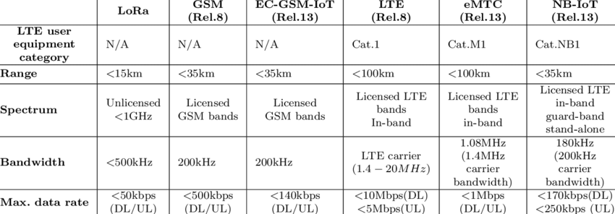

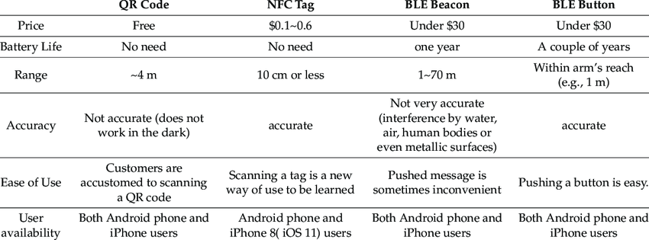

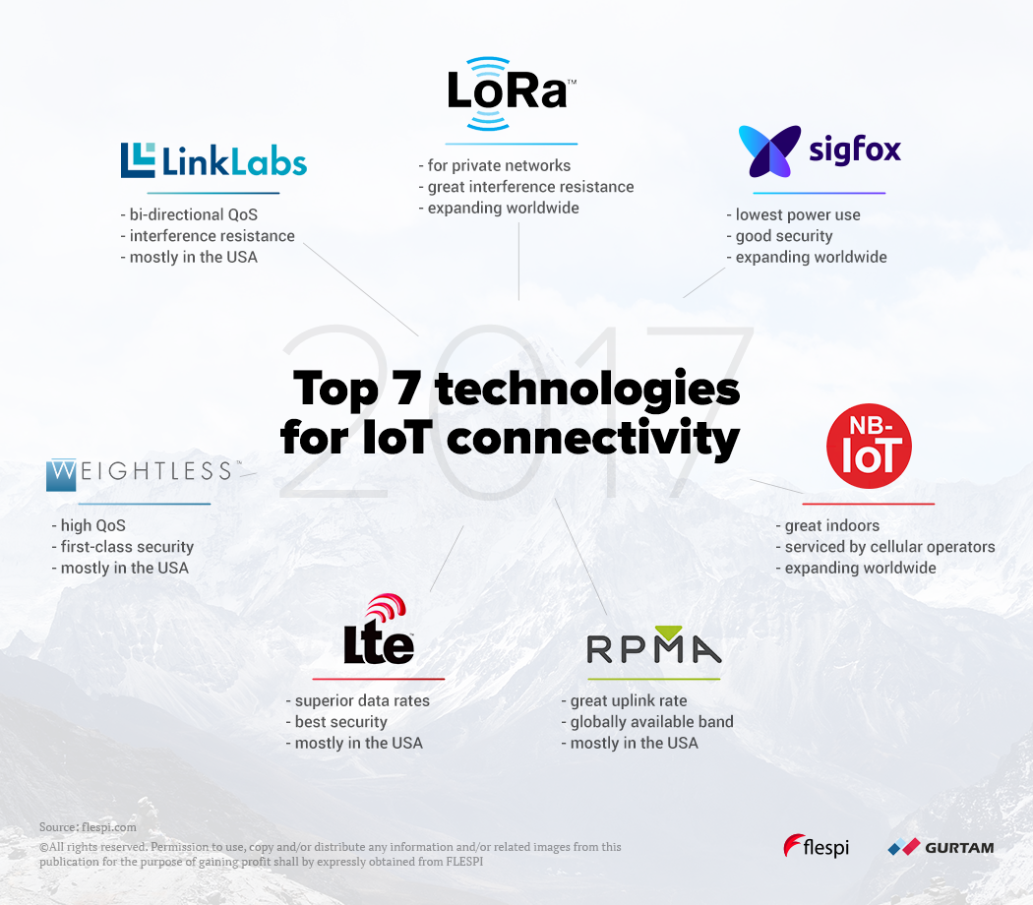

<https://flespi.com/blog/top-7-technologies-for-iot-connectivity-2017>

<https://www.bluetooth.com/blog/wireless-connectivity-options-for-iot-applications-technology-comparison/>

## Recomeço

### Links

DIY WiFi RGB LED Lamp || ESP8266 & Blynk

<https://youtu.be/DkJ1f5UIuak>

<https://youtu.be/2cjufbgOBYo> - Arduino UNO & ESP8266 and control using smartphone

<https://howtomechatronics.com/tutorials/arduino/diy-arduino-robot-arm-with-smartphone-control/>

<https://youtu.be/_B3gWd3A_SI>: DIY Arduino Robot Arm with Smartphone Control

5$ Arduino WiFi Module!? ESP8266 mini Tutorial/Review: https://youtu.be/9QZkCQSHnko

### Informações

VoCore

<https://www.arduinoecia.com.br/comunicacao-arduino-e-raspberry-pi-com-lora/>

Fernando K Tecnologia

Well, there are 3 main factors to consider when choosing radio modules: range, energy usage (which is determined by power and the time it takes to connect and send the message) and speed. So using those, the modules you used (plus a bonus) would have:

1. NRF24: medium-high range, low energy usage, high speed. Example usage: drones, battery-operated IoT devices.

2. LoRa: very long range, variable energy usage (depends heavily on the length of the message due to its low speed), very low speed. Example usage: IoT devices.

3. CC1101 without/with power amplifier: medium/very long range, low/very high energy usage, medium speed. Example usage: walkie-talkies.

4. HC12: long range, low energy usage, low-medium speed. Example usage: battery-operated IoT devices, drones.

5. 433 MHz raw: variable range, low energy usage, variable speed. Example usage: cheap devices.

6. HC05/Bluetooth 3.0: short range, medium energy usage, medium speed. Example usage: robots controlled with a smartphone.

7. Bonus: Wi-Fi: short-medium range, medium-high energy usage, very high speed. Example usage: IoT devices, security cameras.

IMO, the best general-purpose ones are the NRF24, the HC12, Wi-Fi (including ESP-NOW) and Bluetooth LE (which isn't in your comparison). They're easy to use (especially Wi-Fi and Bluetooth LE if you use an ESP8266/32), don't use much energy, have a good range and are fast enough for most applications.

### Tabelação de Preços

Verificar com Tang necessidade e preços, caso seja de interesse.

#### Módulos IOT Arduino

<https://www.curtocircuito.com.br/modulos/internet-das-coisas-iot?p=2>

<https://youtu.be/2ApyndAOI0s> Protocolo CAN -Não mobile

<https://www.fernandok.com/2018/01/esp32-longa-distancia-lorawan.html> Lorawan

**EXCEL**

#### Valores Braço Robótico

**EXCEL**

#### sugestões para tang

##### Cases de Arduino

Case Arduino Uno

Case em plástico ABS para placas compatíveis com Arduino Uno, como Leonardo, Genuino 101 e similares. Mantém a sua placa protegida ao mesmo tempo que disponibiliza acesso aos pinos e terminais da placa.

R$22,90

Case Flip Arduino Uno Transparente

REF: 1AC30

Case em acrílico para placas compatíveis com Arduino Uno R3, com tampa que dá fácil acesso ao microcontrolador e às conexões da placa para colocação de jumpers, shields e outros acessórios.

R$ 19,90

##### Protoshield para Arduino + Mini Protoboard

REF: 1AS03

Este protoshield foi desenvolvido para facilitar o processo de prototipagem, encaixando-se perfeitamente sobre a placa Arduino, fornecendo ao usuário uma área de trabalho com 2 led’s de uso geral, 2 botões e todos os pinos referente ao Arduino usado devido a disposição dos barramentos.

R$17,90

##### Módulo Digispark - Attiny85 – USB

https://www.curtocircuito.com.br/modulo-digispark-attiny85-usb.html

R$19,90

**Overview**

O Módulo Digispark - Attiny85 – USB é uma placa de controle que trabalha com o microcontrolador ATMEL AVR ATTINY85. Ele é considerado um pequeno Arduino Uno, já que trabalha de forma similar e tem basicamente as mesmas configurações, sendo apenas um pouco menos potente, mas com a vantagem de ser de tamanho reduzido.

Módulo Digispark - Attiny85 - USB

O Módulo Digispark - Attiny85 – USB é uma placa de controle que trabalha com o microcontrolador ATMEL AVR ATTINY85. Ele é considerado um pequeno Arduino Uno, já que trabalha de forma similar e tem basicamente as mesmas configurações, sendo apenas um pouco menos potente, mas com a vantagem de ser muito pequeno, quase do tamanho de uma moeda. O módulo é muito utilizado em projetos eletrônicos em que há a necessidade de trabalhar em um espaço reduzido, além de ser programável via USB com comunicação serial.

O Módulo Digispark - Attiny85 – USB possui 6 portas lógicas, das quais 3 podem ser utilizadas como PWM, permite alimentação via USB 5V ou por fonte com tensões entre 7 a 35V, ademais, possui um regulador on-board de 150mA com 5V e 8K de memória flash. Para fazer o upload do programa, pode ser utilizado a IDE do Arduino.

Principais Características:

Microcontrolador ATtiny85;

Memória flash: 8Kb;

EEPROM: 512 bytes;

SRAM: 512 bytes;

6 pinos de I/O;

Tensão de operação: 5VDC (USB) – 7 a 35V (alimentação externa);

Interfaces I2C e SPI;

Conexão USB;

Conversor analógico digital em 4 pinos;

Modulação PWM em 3 pinos;

Dimensões: 26 x 18 x 5mm;

Datasheet: Módulo Digispark - ATtiny85 - USB

Acompanha:

01 - Módulo Digispark - Attiny85 - USB

01 - Barra de pinos

##### Carregador Bateria Lithinum 1A com Proteção - TP4056

https://www.curtocircuito.com.br/carregador-bateria-lithinum-1a-com-protecao-tp4056.html

R$5,80

# FIM